ML MODELS

🟢 PHASE 3: Core Machine Learning Algorithms

🔹 Supervised Learning

Regression
Linear Regression
Ridge & Lasso
Polynomial Regression

Classification
Logistic Regression
KNN
Naive Bayes
Decision Trees
Random Forest
SVM

🔹 Unsupervised Learning
K-Means
Hierarchical Clustering
DBSCAN
PCA
t-SNE

Supervised Learning Algorithms

Classification Algorithms (predict categories/labels)
Logistic Regression
Decision Tree Classifier
Random Forest Classifier
Support Vector Machine (SVM)
k-Nearest Neighbors (k-NN)
Naive Bayes
Gradient Boosting Classifiers (XGBoost, LightGBM, CatBoost)
Neural Networks (for classification)

Regression Algorithms (predict continuous values)
Linear Regression
Polynomial Regression
Ridge Regression / Lasso Regression / ElasticNet (regularized linear models)
Decision Tree Regressor
Random Forest Regressor
Support Vector Regression (SVR)
Gradient Boosting Regressors (XGBoost, LightGBM, CatBoost)
Neural Networks (for regression)
o both classification and regression, just with different configurations.

## 2. Unsupervised Learning (Finding Hidden Patterns)
Here, you don't have a target to predict. You're looking for structure in the data itself.

For Clustering (Grouping similar data points):
K-Means Clustering: The most famous and widely used clustering algorithm. It's simple to understand and implement.
DBSCAN: An excellent algorithm for finding clusters of arbitrary shapes and identifying outliers.

For Dimensionality Reduction (Simplifying your data):
Principal Component Analysis (PCA): The most important dimensionality reduction technique. It's used everywhere to reduce the number of features while retaining the most important information

## 3. Deep Learning (Neural Networks)
This is a subfield of ML but is essential for working with unstructured data like images and text.
Artificial Neural Networks (ANNs): For complex tabular data problems where other models fall short.
Convolutional Neural Networks (CNNs): The standard for any task involving image data.
Recurrent Neural Networks (RNNs) / Transformers: The standard for sequential data, like text (NLP) or time series.

- regression

🔹 1. Linear Regression

📌 What it is:
An algorithm to predict a continuous value (numbers).
It tries to fit a straight line through the data points.
Formula:
y=mx+by = m x + by=mx+b
(or with multiple features: y=w1x1+w2x2+...+by = w_1x_1 + w_2x_2 + ... + by=w1​x1​+w2​x2​+...+b)

📌 Why we use it:
Predicting prices (house price, car price, salary).
Forecasting sales, stock prices, etc.

📌 Practical Example: Predict House Price

import numpy as np
import matplotlib.pyplot as plt
from sklearn.linear_model import LinearRegression

# Training data
X = np.array([[500], [1000], [1500], [2000], [2500]]) # house size in sq.ft
y = np.array([100000, 200000, 250000, 350000, 400000]) # price

# Train model
model = LinearRegression()
model.fit(X, y)

# Predict price of a 1800 sq.ft house
predicted_price = model.predict([[1800]])
print("Predicted Price:", predicted_price[0])

# Plot
plt.scatter(X, y, color="blue") # real data
plt.plot(X, model.predict(X), color="red") # regression line
plt.xlabel("House Size (sq.ft)")
plt.ylabel("Price")
plt.show()

Polynomial Regression

1️⃣ What is Polynomial Regression?
Polynomial Regression is an extension of Linear Regression where we model the relationship between input XXX and output yyy as an nth-degree polynomial instead of a straight line.
Even though it is called polynomial, it is still a linear model (because it is linear in parameters).
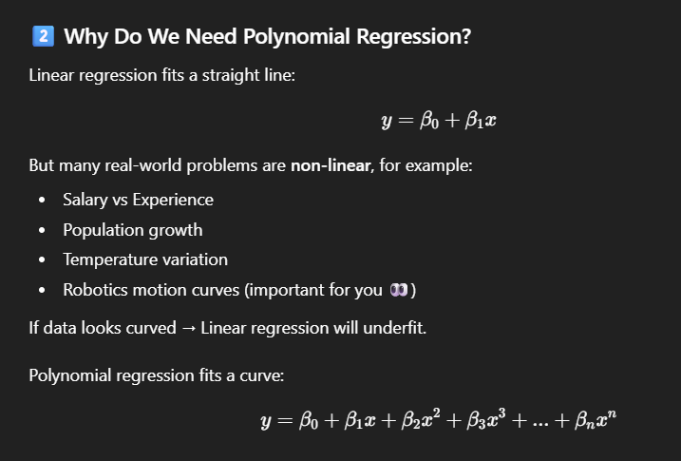

import numpy as np
import matplotlib.pyplot as plt
from sklearn.linear_model import LinearRegression
from sklearn.preprocessing import PolynomialFeatures

# Data
X = np.array([1,2,3,4,5]).reshape(-1,1)
y = np.array([1,4,9,16,25])

# Transform features
poly = PolynomialFeatures(degree=2)
X_poly = poly.fit_transform(X)

# Train model
model = LinearRegression()
model.fit(X_poly, y)

# Prediction
y_pred = model.predict(X_poly)

# Plot
plt.scatter(X,y)
plt.plot(X,y_pred,color='red')
plt.show()

L1 AND L2 regularization
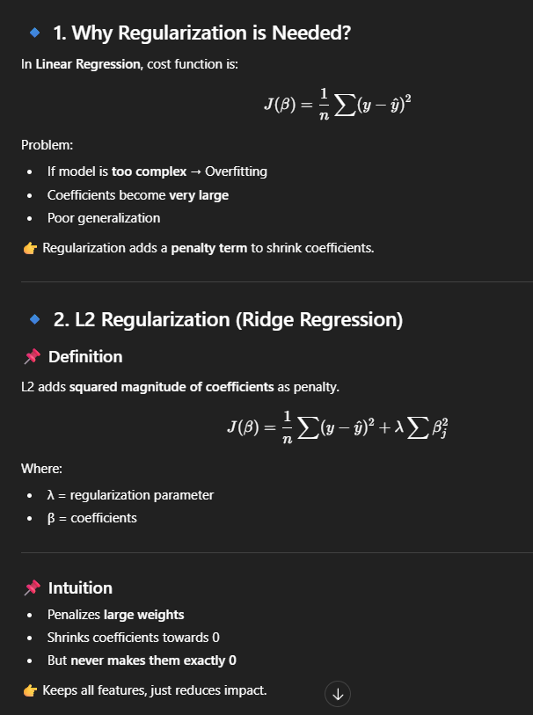

L1 regularization(lesso)
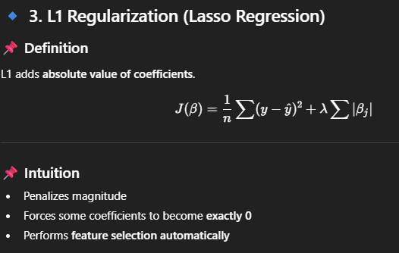

🔹 6. Complete Python Code Example

📌 Step 1: Import Libraries
import numpy as np
import pandas as pd
import matplotlib.pyplot as plt
from sklearn.linear_model import LinearRegression, Ridge, Lasso
from sklearn.model_selection import train_test_split
from sklearn.metrics import mean_squared_error

📌 Step 2: Create Sample Dataset
# Generate data
np.random.seed(42)
X = np.random.randn(100, 5)
y = 3*X[:,0] + 2*X[:,1] + np.random.randn(100)
X_train, X_test, y_train, y_test = train_test_split(X, y, test_size=0.2)

📌 Step 3: Linear Regression (Without Regularization)
lr = LinearRegression()
lr.fit(X_train, y_train)
print("Linear Coefficients:", lr.coef_)

📌 Step 4: Ridge Regression (L2)
ridge = Ridge(alpha=1.0)
ridge.fit(X_train, y_train)
print("Ridge Coefficients:", ridge.coef_)

📌 Step 5: Lasso Regression (L1)
lasso = Lasso(alpha=0.1)
lasso.fit(X_train, y_train)
print("Lasso Coefficients:", lasso.coef_)

📌 Step 6: Compare MSE
models = [lr, ridge, lasso]
for model in models:
y_pred = model.predict(X_test)
print(model.__class__.__name__,
mean_squared_error(y_test, y_pred))

.
Classification
Logistic regression

🔷 1️⃣ Definition of Logistic Regression
Logistic Regression is a supervised machine learning classification algorithm used to predict the probability of a binary outcome (0 or 1) using the sigmoid function.
👉 Even though it is called “regression”, it is mainly used for classification problems.

🔷 2️⃣ One Simple Example

Example: Email Spam Detection
Input: Email features (length, keywords, links, etc.)
Output:
1 → Spam
0 → Not Spam
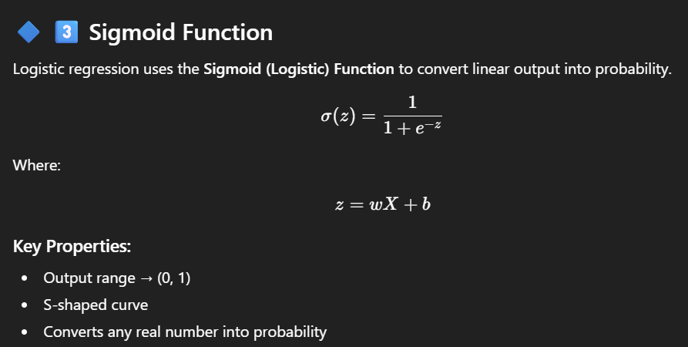
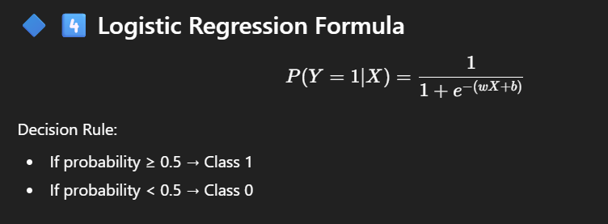

🔷 5️⃣ Python Code for Logistic Regression

Example: Breast Cancer Dataset
# Step 1: Import libraries
import numpy as np
import pandas as pd
from sklearn.datasets import load_breast_cancer
from sklearn.model_selection import train_test_split
from sklearn.linear_model import LogisticRegression
from sklearn.metrics import accuracy_score
# Step 2: Load dataset
data = load_breast_cancer()
X = data.data
y = data.target
# Step 3: Train-test split
X_train, X_test, y_train, y_test = train_test_split(
X, y, test_size=0.2, random_state=42
)
# Step 4: Create model
model = LogisticRegression(max_iter=5000)
# Step 5: Train model
model.fit(X_train, y_train)
# Step 6: Predict
y_pred = model.predict(X_test)
# Step 7: Accuracy
print("Accuracy:", accuracy_score(y_test, y_pred))

Classification

Knn

# 2. K-Nearest Neighbors (KNN)
- Nearest Neighbors (KNN) is a simple, supervised machine learning algorithm that can be used for both classification and regression. It's known as a "lazy learner" because it doesn't build a complex model during the training phase. Instead, it just stores the entire training dataset.
# Step 1: Import necessary libraries
import numpy as np
import matplotlib.pyplot as plt
from sklearn.datasets import make_classification
from sklearn.model_selection import train_test_split
from sklearn.preprocessing import StandardScaler
from sklearn.neighbors import KNeighborsClassifier
from sklearn.metrics import accuracy_score

# Step 2: Generate synthetic classification data
X, y = make_classification(n_samples=200, n_features=2, n_redundant=0,
n_informative=2, n_clusters_per_class=1,
flip_y=0.1, random_state=42)

# Step 3: Split data into training and testing sets
X_train, X_test, y_train, y_test = train_test_split(X, y, test_size=0.3, random_state=42)

# Step 4: CRITICAL - Scale the features
# KNN is sensitive to the scale of data
scaler = StandardScaler()
X_train_scaled = scaler.fit_transform(X_train)
X_test_scaled = scaler.transform(X_test) # Use the same scaler fitted on the training data

# Step 5: Create and train the KNN model
k = 5
knn_model = KNeighborsClassifier(n_neighbors=k)
knn_model.fit(X_train_scaled, y_train)

# Step 6: Make predictions and evaluate the model
y_pred = knn_model.predict(X_test_scaled)
accuracy = accuracy_score(y_test, y_pred)

print(f"The number of neighbors (k) is: {k}")
print(f"Accuracy of the KNN model on the test set: {accuracy:.2f}")

# Step 7: Visualize the results (optional, for 2D data)
plt.figure(figsize=(10, 6))
# Plot test data points, color-coded by their true class
plt.scatter(X_test_scaled[:, 0], X_test_scaled[:, 1], c=y_test, cmap='viridis',
edgecolor='k', s=80, label='True Classes')
plt.title(f'KNN Classification Results (Accuracy: {accuracy:.2f})')
plt.xlabel('Feature 1 (Scaled)')
plt.ylabel('Feature 2 (Scaled)')
plt.legend()
plt.grid(True)
plt.show()

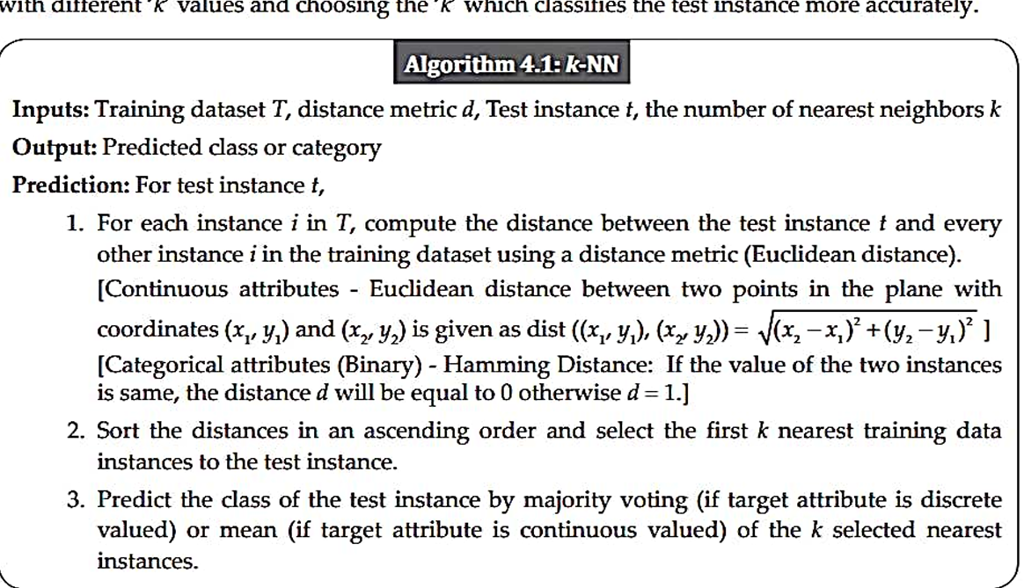

📌 Logistic Regression

1️⃣ Definition
Logistic Regression is a supervised machine learning algorithm used for classification problems, especially binary classification (0 or 1, Yes or No, True or False).
Even though it is called regression, it is used for classification because it predicts the probability of a class using the sigmoid function.
Example:
Email → Spam (1) or Not Spam (0)
Student → Pass (1) or Fail (0)
Disease → Present (1) or Not Present (0)
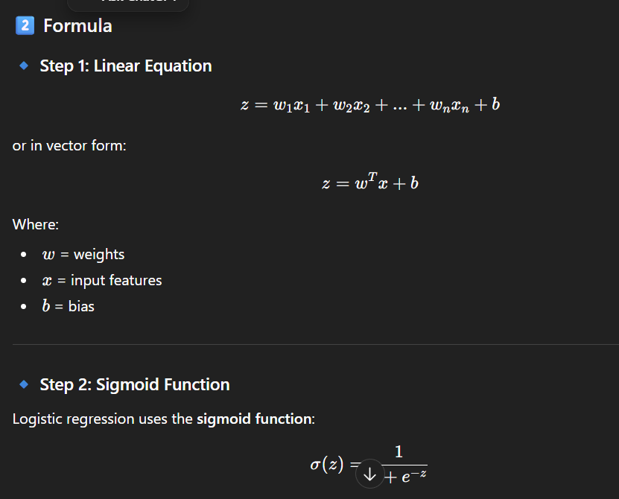

code
from sklearn.linear_model import LogisticRegression
from sklearn.model_selection import train_test_split
from sklearn.metrics import accuracy_score
import numpy as np

# Sample data
X = np.array([[2,3],[1,5],[2,8],[5,1],[6,2]])
y = np.array([0,0,0,1,1])

# Split data
X_train, X_test, y_train, y_test = train_test_split(X, y, test_size=0.2)

# Model
model = LogisticRegression()
model.fit(X_train, y_train)

# Prediction
y_pred = model.predict(X_test)

print("Accuracy:", accuracy_score(y_test, y_pred))

1. What is Naive Bayes?
Naive Bayes is a supervised machine learning classification algorithm based on Bayes Theorem.
It is called “Naive” because it assumes that all features are independent of each other, which is usually not true in real-world data.
Despite this strong assumption, it works very well for many problems like text classification, spam detection, and sentiment analysis.

Example
Suppose we want to classify an email as:
Spam
Not Spam
Naive Bayes calculates the probability of the email belonging to each class and chooses the class with the highest probability.
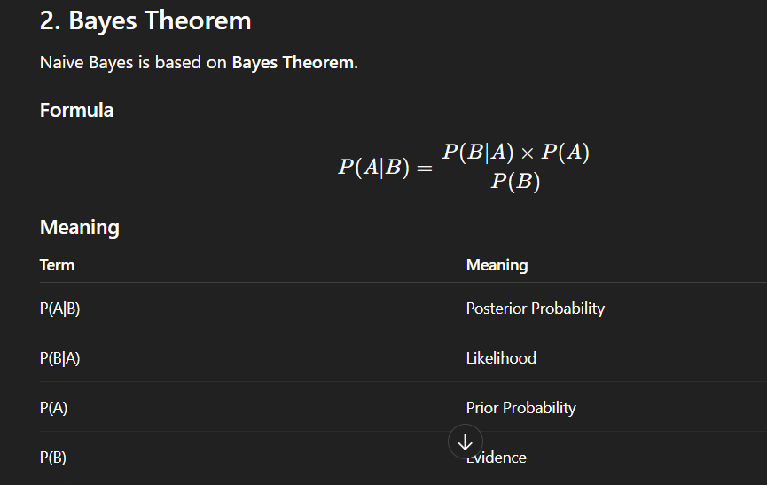

4. Types of Naive Bayes
There are 3 main types.

1️⃣ Gaussian Naive Bayes
Used when features are continuous numbers.
Example:
height
weight
age
income
Assumes data follows Normal Distribution.

2️⃣ Multinomial Naive Bayes
Used for text classification.
Example:
Spam detection
Sentiment analysis
Document classification
Works with word counts.

3️⃣ Bernoulli Naive Bayes
Used when features are binary.
Example:
word_free | word_offer
1 | 0
1 | 1
Values only 0 or 1.

9. When to Use Naive Bayes
Used for:
Spam filtering
Sentiment analysis
Text classification
Recommendation systems
Medical diagnosis

10. Python Implementation

Step 1 – Import Libraries
import pandas as pd
from sklearn.model_selection import train_test_split
from sklearn.naive_bayes import GaussianNB
from sklearn.metrics import accuracy_score

Step 2 – Create Dataset
data = {
"height":[150,160,170,180,175,165],
"weight":[50,60,70,80,75,65],
"gender":[0,0,1,1,1,0]
}
df = pd.DataFrame(data)
0 → Female
1 → Male

Step 3 – Split Dataset
X = df[["height","weight"]]
y = df["gender"]
X_train,X_test,y_train,y_test = train_test_split(X,y,test_size=0.2,random_state=42)

Step 4 – Train Model
model = GaussianNB()
model.fit(X_train,y_train)

Step 5 – Prediction
y_pred = model.predict(X_test)

Step 6 – Accuracy
print("Accuracy:",accuracy_score(y_test,y_pred))

11. Example Prediction
model.predict([[172,72]])
Output:
[1]
Meaning → Male

12. Multinomial Naive Bayes Example (Text)
from sklearn.feature_extraction.text import CountVectorizer
from sklearn.naive_bayes import MultinomialNB
text = [
"free money offer",
"hi how are you",
"claim your free prize",
"lets meet tomorrow"
]
label = [1,0,1,0]
vector = CountVectorizer()
X = vector.fit_transform(text)
model = MultinomialNB()
model.fit(X,label)
test = vector.transform(["free prize"])
print(model.predict(test))
Output
[1]
Meaning → Spam

Decision Tree in Machine Learning (Complete Guide)

1. What is a Decision Tree?
A Decision Tree is a supervised machine learning algorithm used for classification and regression problems.
It works like a flowchart:
Each internal node → decision based on a feature
Each branch → outcome of the decision
Each leaf node → final prediction
Age
/ \
<30 >30
/ \
Student Income
/ \ / \
Yes No High Low
Buy No Buy No

4. How Decision Tree Works
Steps:

Step 1
Select the best feature for splitting

Step 2
Split dataset into subsets

Step 3
Repeat splitting until:
Pure nodes reached
Maximum depth reached
No features left
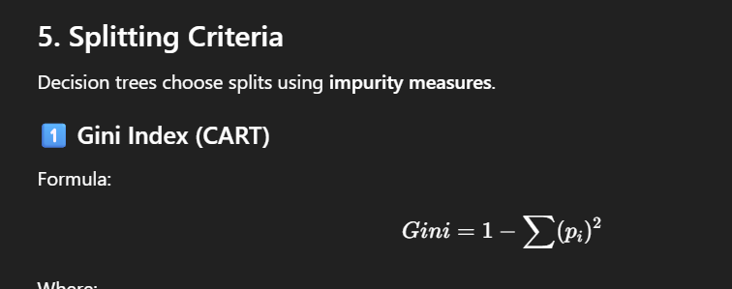

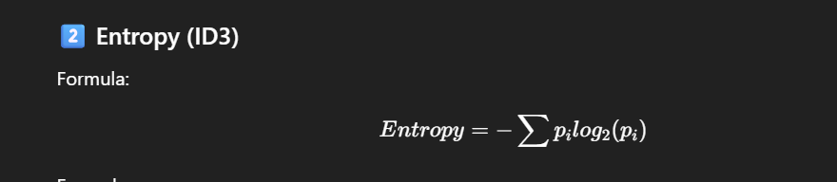
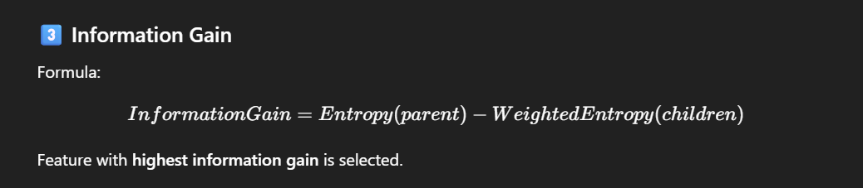
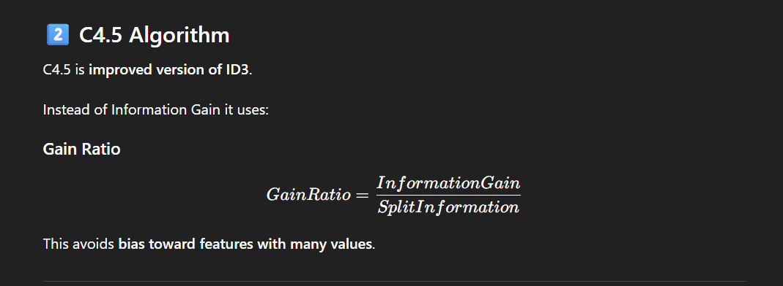

1️⃣ CART Classification Example (Python)
from sklearn.datasets import load_iris
from sklearn.tree import DecisionTreeClassifier
from sklearn.model_selection import train_test_split
# load data
data = load_iris()
X = data.data
y = data.target
# split
X_train,X_test,y_train,y_test = train_test_split(
X,y,test_size=0.2,random_state=42
)
# model
model = DecisionTreeClassifier(criterion="gini") #criterion=”entrophy”if we want to split data based on entropy information
# train
model.fit(X_train,y_train)
# predict
y_pred = model.predict(X_test)

2️⃣ CART Regression Example
from sklearn.tree import DecisionTreeRegressor
from sklearn.model_selection import train_test_split
import numpy as np
X = np.array([[1],[2],[3],[4],[5]])
y = np.array([5,10,15,20,25])
# split
X_train,X_test,y_train,y_test = train_test_split(
X,y,test_size=0.2
)
# model
model = DecisionTreeRegressor(max_depth=3)
model.fit(X_train,y_train)
pred = model.predict(X_test)
print(pred)

Random Forest

Random Forest in Machine Learning (Complete Guide)

1️⃣ What is Random Forest?
Random Forest is an ensemble machine learning algorithm that combines multiple decision trees to make better predictions.
Instead of relying on one decision tree, Random Forest builds many trees and combines their predictions.
Basic idea:
Multiple Decision Trees → Combine Predictions → Final Output

2️⃣ Random Forest Concept
Example:
Tree 1 → Class A
Tree 2 → Class B
Tree 3 → Class A
Tree 4 → Class A
Tree 5 → Class B
Final prediction:
Majority Vote → Class A
This is called Voting.

4️⃣ Why Random Forest is Used
Decision trees have a big problem:
Overfitting
Random Forest solves this by:
Bagging + Random Feature Selection

5️⃣ Two Important Concepts

1️⃣ Bagging (Bootstrap Aggregation)
Steps:
Random samples taken from dataset
Multiple trees trained
Predictions combined
Example:
Dataset = 100 rows
Each tree trained on random 100 rows with replacement.

2️⃣ Random Feature Selection
Each tree uses random subset of features.
Example:
Total features = 10
Each split uses = sqrt(10) ≈ 3 features
This makes trees different from each other.

6️⃣ How Random Forest Works (Step by Step)

Step 1
Take bootstrap samples
Original Dataset → Random Samples

Step 2
Train multiple decision trees
Tree1
Tree2
Tree3
Tree4
Tree5

Step 3
Each tree predicts output

Step 4
Combine predictions
Classification → Majority Vote
Regression → Average

7️⃣ Random Forest for Classification
Example:
Spam detection
Disease prediction
Customer churn prediction
Fraud detection
Final prediction method:
Majority Voting

8️⃣ Random Forest for Regression
Example:
House price prediction
Stock prediction
Temperature prediction
Final prediction method:
Average of all trees

9️⃣ Important Hyperparameters
Parameter | Meaning
n_estimators | Number of trees
max_depth | Maximum tree depth
min_samples_split | Minimum samples to split
min_samples_leaf | Minimum samples in leaf
max_features | Number of features considered
bootstrap | Sampling method
Example:
RandomForestClassifier(n_estimators=100)

🔟 Random Forest Classification Code
Example using Iris dataset
from sklearn.datasets import load_iris
from sklearn.model_selection import train_test_split
from sklearn.ensemble import RandomForestClassifier
from sklearn.metrics import accuracy_score
# load dataset
data = load_iris()
X = data.data
y = data.target
# split dataset
X_train, X_test, y_train, y_test = train_test_split(
X, y, test_size=0.2, random_state=42
)
# model
model = RandomForestClassifier(
n_estimators=100,
random_state=42
)
# train
model.fit(X_train, y_train)
# predict
y_pred = model.predict(X_test)
# accuracy
print("Accuracy:", accuracy_score(y_test, y_pred))

1️⃣1️⃣ Random Forest Regression Code
from sklearn.ensemble import RandomForestRegressor
from sklearn.model_selection import train_test_split
import numpy as np
# dataset
X = np.array([[1],[2],[3],[4],[5]])
y = np.array([5,10,15,20,25])
# split
X_train, X_test, y_train, y_test = train_test_split(
X, y, test_size=0.2
)
# model
model = RandomForestRegressor(
n_estimators=100
)
# train
model.fit(X_train, y_train)
# predict
pred = model.predict(X_test)
print(pred)

1️⃣2️⃣ Feature Importance in Random Forest
Random Forest can measure feature importance.
Example:
import pandas as pd
importance = model.feature_importances_
print(importance)
Example output:
Age → 0.45
Income → 0.30
Education → 0.15
Gender → 0.10

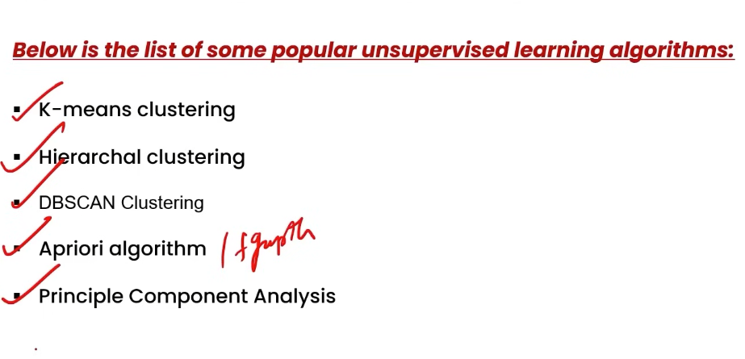
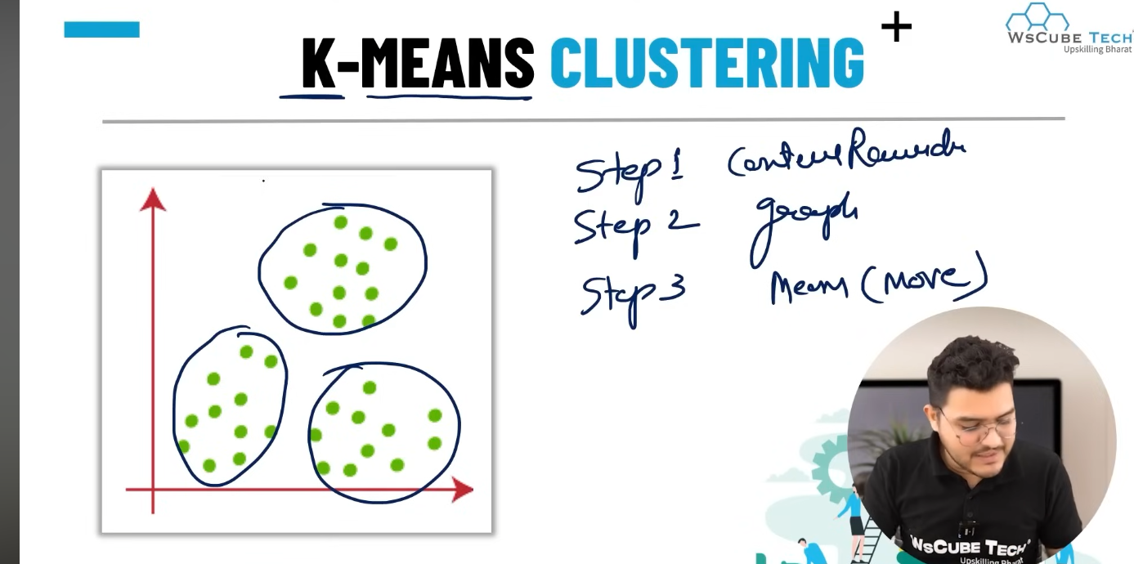

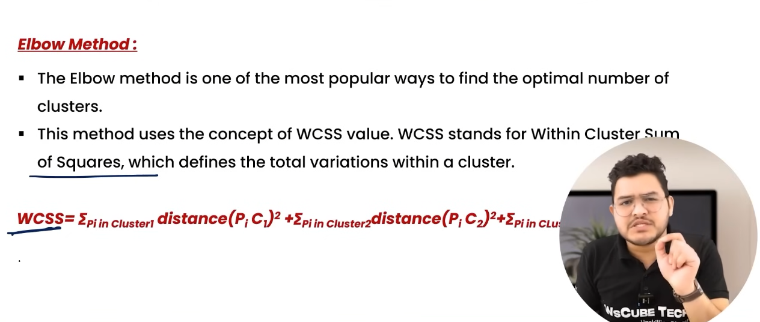

Unsupervised learning

Kmeans

K-Means Clustering (Complete Guide)

1. What is K-Means?
K-Means is an unsupervised machine learning algorithm used for clustering.
It groups similar data points into K clusters based on their distance from the cluster center (centroid).
📌 Key Idea:
Data points that are similar should belong to the same cluster.
Example:
Customer segmentation
Image compression
Document clustering
Market analysis

2. Why is it called K-Means?
K → number of clusters
Means → average of points in a cluster (centroid)
Each cluster is represented by its mean (centroid).
Example:
If
K = 3
Then data will be divided into 3 clusters.

3. Example
Suppose we have data of customers based on income and spending score.
Customer | Income | Spending
A | 20 | 30
B | 25 | 35
C | 80 | 90
D | 85 | 95
K-Means might form:
Cluster 1 → Low income customers
Cluster 2 → High income customers

4. K-Means Algorithm (Step by Step)

Step 1: Choose K
Choose number of clusters.
Example:
K = 3

Step 2: Initialize Centroids
Randomly select K points as centroids.
Example:
C1 = (20,30)
C2 = (80,90)
C3 = (50,60)
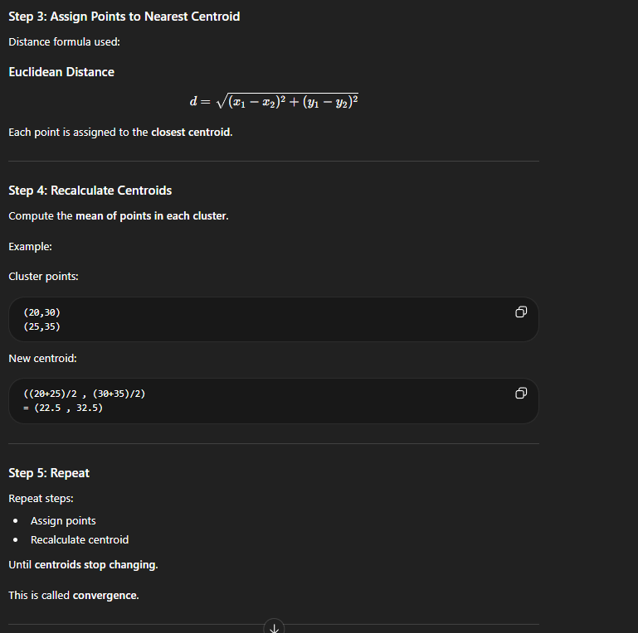

6. Choosing the Best K

Elbow Method
Plot:
K vs WCSS
Graph looks like an arm elbow.
The elbow point is the best K.
Example:
K = 1 → WCSS = 1000
K = 2 → WCSS = 500
K = 3 → WCSS = 200
K = 4 → WCSS = 180
Best K = 3

7. K-Means Python Implementation

Step 1: Import Libraries
import numpy as np
import pandas as pd
import matplotlib.pyplot as plt
from sklearn.cluster import KMeans

Step 2: Create Dataset
data = {
"x":[1,2,3,8,9,10],
"y":[2,3,4,8,9,10]
}
df = pd.DataFrame(data)

Step 3: Apply K-Means
kmeans = KMeans(n_clusters=2)
kmeans.fit(df)

Step 4: Get Clusters
labels = kmeans.labels_
print(labels)
Output example:
[0 0 0 1 1 1]

Step 5: Get Centroids
centroids = kmeans.cluster_centers_
print(centroids)
Example output:
[[2,3]
[9,9]]

Step 6: Visualization
plt.scatter(df["x"], df["y"], c=labels)
plt.scatter(centroids[:,0], centroids[:,1],
color="red", marker="X", s=200)
plt.show()

8. Using Elbow Method
wcss = []
for i in range(1,11):
kmeans = KMeans(n_clusters=i)
kmeans.fit(df)
wcss.append(kmeans.inertia_)
plt.plot(range(1,11), wcss)
plt.xlabel("Number of Clusters")
plt.ylabel("WCSS")
plt.show()

9. Important Parameters in KMeans
KMeans(
n_clusters=3,
init='k-means++',
max_iter=300,
n_init=10,
random_state=42
)

n_clusters
Number of clusters.

Hierarchical Clustering (Complete Guide)

1. What is Hierarchical Clustering?
Hierarchical Clustering is an unsupervised machine learning algorithm used to group similar data points into clusters.
Instead of directly forming clusters like K-Means, it builds a hierarchy (tree structure) of clusters.
This tree is called a Dendrogram.
📌 Key Idea
Start with small clusters and gradually merge them OR start with one big cluster and divide it.

2. Types of Hierarchical Clustering
There are two types.

1️⃣ Agglomerative (Bottom-Up)
Most commonly used.
Steps:
Start with each point as its own cluster
Merge the closest clusters
Continue until all points form one cluster
Example:
Initial clusters
A B C D
Step 1
(A,B) C D
Step 2
(A,B,C) D
Step 3
(A,B,C,D)

2️⃣ Divisive (Top-Down)
Opposite approach.
Steps:
Start with all points in one cluster
Split clusters recursively.
Example:
(A,B,C,D)
Split
(A,B) (C,D)
Split again
A B C D

3. What is a Dendrogram?
A Dendrogram is a tree diagram showing cluster merging.
It helps decide optimal number of clusters.
Example structure:
----A
----|
| ----B
----|
| ----C
| ----|
----D
The height represents distance between clusters.
Cutting the tree at a certain level gives clusters.

4. Algorithm (Agglomerative)
Step-by-step process.

Step 1
Treat every point as a cluster.
Example:
A B C D

Step 2
Calculate distance matrix
 | A | B | C | D
A | 0
B | 2 | 0
C | 6 | 5 | 0
D | 10 | 9 | 4 | 0

Step 3
Find closest clusters
Example:
distance(A,B) = 2
Merge:
(A,B)

Step 4
Update distance matrix.

Step 5
Repeat until one cluster remains.

5. Linkage Methods
When merging clusters we must decide distance between clusters.
This is called linkage criteria.

1️⃣ Single Linkage
Distance between closest points.
D(A,B)=min(d(a,b))D(A,B) = min(d(a,b))D(A,B)=min(d(a,b))
Example:
Cluster A → {1,2}
Cluster B → {7,8}
Distance:
min(|2-7|)

2️⃣ Complete Linkage
Distance between farthest points.
D(A,B)=max(d(a,b))D(A,B) = max(d(a,b))D(A,B)=max(d(a,b))
Produces compact clusters.

3️⃣ Average Linkage
Average distance between clusters.
D(A,B)=average(d(a,b))D(A,B) = average(d(a,b))D(A,B)=average(d(a,b))

4️⃣ Ward Linkage
Minimizes variance within clusters.
Most commonly used.

7. Python Implementation

Step 1: Import Libraries
import numpy as np
import pandas as pd
import matplotlib.pyplot as plt
from sklearn.cluster import AgglomerativeClustering
from scipy.cluster.hierarchy import dendrogram, linkage

8. Create Dataset
data = [
[1,2],
[2,3],
[3,4],
[8,8],
[9,9],
[10,10]
]
df = pd.DataFrame(data, columns=["x","y"])

9. Plot Dendrogram
linked = linkage(df, method="ward")
plt.figure(figsize=(8,5))
dendrogram(linked)
plt.title("Dendrogram")
plt.show()
The dendrogram shows how clusters merge.
You choose cluster count by cutting the tree.

10. Apply Hierarchical Clustering
model = AgglomerativeClustering(
n_clusters=2,
linkage='ward')
labels = model.fit_predict(df)
print(labels)
Output:
[0 0 0 1 1 1]

11. Visualization
plt.scatter(df["x"], df["y"], c=labels)
plt.xlabel("X")
plt.ylabel("Y")
plt.show()

12. Important Parameters

n_clusters
Number of clusters.
Example:
n_clusters = 3

linkage
Options:
ward
complete
average
single
Default:
ward

affinity (distance metric)
Example:
euclidean
manhattan
cosine

DBSCAN (Density-Based Spatial Clustering of Applications with Noise)

1. What is DBSCAN?
DBSCAN is an unsupervised clustering algorithm that groups data points based on density.
Instead of using distance to centroids (like K-Means), it groups points where many points exist close together.
Key idea:
Clusters are areas with high density, separated by low-density regions.
It can also detect outliers (noise).

2. Why DBSCAN is Important
K-Means problems:
Need to choose K
Cannot detect outliers
Works only with spherical clusters
DBSCAN solves these problems.
DBSCAN advantages:
✔ No need to choose K
✔ Detects noise/outliers
✔ Works with arbitrary shaped clusters

3. Important Parameters
DBSCAN mainly uses two parameters.

1️⃣ eps (ε)
Maximum distance between two points to be considered neighbors.
Example:
eps = 0.5
Points within this radius are neighbors.

2️⃣ min_samples (MinPts)
Minimum number of points required to form a dense region.
Example:
min_samples = 5
If a point has 5 neighbors within eps, it becomes a core point.

4. Types of Points in DBSCAN
There are three types of points.

1️⃣ Core Point
A point is a core point if it has at least MinPts neighbors within eps.
Example:
eps = 1
min_samples = 4
If a point has 4 points within radius 1, it is a core point.

2️⃣ Border Point
A point that:
Is not a core point
But lies near a core point
It belongs to the cluster.

3️⃣ Noise Point (Outlier)
A point that:

Is not a core poin
Not close to any core point
It is labeled as noise.
Example label:
-1

5. DBSCAN Algorithm (Step by Step)

Step 1
Choose parameters:
eps
min_samples

Step 2
Pick an unvisited point.

Step 3
Find all points within eps radius.

Step 4
If neighbors ≥ min_samples
➡ It becomes a core point
➡ Create a new cluster

Step 5
Expand cluster by adding all density-connected points.

Step 6
Repeat until all points are visited.

6. Example
Dataset:
1,2
2,2
2,3
8,8
9,8
25,25
Clusters formed:
Cluster 1
1,2
2,2
2,3
Cluster 2
8,8
9,8
Noise
25,25

7. Density Reachability
A point p is density reachable from q if:
q is a core point
p is within eps distance

8. Density Connectivity
Two points are density connected if:
They share a chain of density reachable points.
This forms clusters.

9. Python Implementation

Step 1: Import Libraries
import numpy as np
import pandas as pd
import matplotlib.pyplot as plt

from sklearn.cluster import DBSCAN

10. Create Dataset
data = [
[1,2],
[2,2],
[2,3],
[8,8],
[9,8],
[25,25]
]

df = pd.DataFrame(data, columns=["x","y"])

11. Apply DBSCAN
model = DBSCAN(eps=2, min_samples=2)

labels = model.fit_predict(df)

print(labels)
Example Output
[0 0 0 1 1 -1]
Explanation
Cluster 0 → first group
Cluster 1 → second group
-1 → noise

12. Visualization
plt.scatter(df["x"], df["y"], c=labels)

plt.xlabel("X")
plt.ylabel("Y")

plt.show()
Noise points appear in separate color.

13. Important Parameters

eps
Maximum distance between neighbors.
Example:
eps = 0.5

min_samples
Minimum points required for a cluster.
Example:
min_samples = 5

metric
Distance metric.
Options:
euclidean
manhattan
cosine
Default:
euclidean

15. Advantages
✔ Detects outliers
✔ No need to choose K
✔ Works for arbitrary shaped clusters
✔ Robust to noise

16. Disadvantages
❌ Hard to choose eps
❌ Not good for varying density clusters
❌ Performance decreases in high-dimensional data

18. DBSCAN vs K-Means vs Hierarchical
Feature | K-Means | Hierarchical | DBSCAN
Need K | Yes | No | No
Outlier detection | No | No | Yes
Shape of clusters | Spherical | Any | Any
Large datasets | Good | Poor | Moderate

19. Real World Applications
DBSCAN is widely used in:

1️⃣ Anomaly Detection
Example:
Fraud detection.

2️⃣ Geographic Data
Finding hotspots on maps.

3️⃣ Image Processing
Detecting objects.

4️⃣ Recommendation Systems
User behavior clustering.

PCA (Principal Component Analysis) – Complete Guide

1. What is PCA?
Principal Component Analysis (PCA) is a dimensionality reduction technique used to reduce the number of features while preserving the maximum information (variance) in the dataset.
It converts many correlated variables into a smaller number of uncorrelated variables called Principal Components.
📌 Key idea:
Reduce dimensions of data while keeping most of the information.
Example:
Original dataset features
Height
Weight
Age
Income
Education
After PCA
PC1
PC2
PC3

2. Why PCA is Needed
Real-world datasets often have many features.
Problems with high dimensions:
High computation cost
Overfitting
Hard to visualize
Redundant information
This is called Curse of Dimensionality.
PCA solves this by reducing features.

3. Example
Suppose we have two correlated features:
Height
Weight
Taller people usually weigh more.
So both features contain similar information.
PCA transforms them into:
PC1 → Maximum variance
PC2 → Remaining variance
Usually PC1 captures most information.

4. What are Principal Components?
Principal Components are new axes created from original data.
Properties:
✔ Orthogonal (perpendicular)
✔ Uncorrelated
✔ Capture maximum variance
Example:
Original axes → X , Y

PCA axes → PC1 , PC2
PC1 direction has maximum variance.

5. PCA Intuition
Imagine data points forming an elongated cloud.
Instead of measuring along X and Y axes, PCA rotates axes to align with the direction of maximum spread.
So:
PC1 → direction of maximum variance
PC2 → second maximum variance

6. Steps in PCA Algorithm
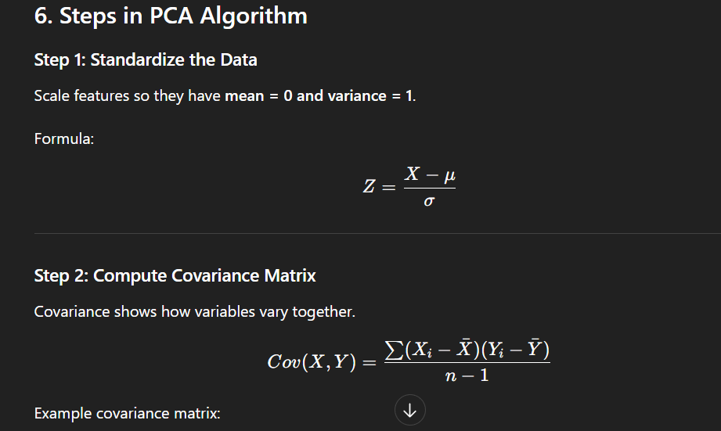
Example covariance matrix:
| var(X) cov(X,Y) |
| cov(Y,X) var(Y) |

Step 3: Compute Eigenvalues and Eigenvectors
Eigenvectors → directions of principal components
Eigenvalues → amount of variance captured
Example:
Eigenvector1 → PC1
Eigenvector2 → PC2

Step 4: Sort Eigenvalues
Sort from highest to lowest variance.
Example:
PC1 → 70% variance
PC2 → 20% variance
PC3 → 10% variance

Step 5: Select Top Components
Choose components that explain most variance.
Example:
PC1 + PC2 = 90% variance
So we keep 2 components instead of 3.

Step 6: Transform Data
Project original data onto principal component axes.
Result:
Reduced dataset

7. Mathematical Objective of PCA
PCA maximizes the variance:
[
\text{Maximize } Var(W^T X)
]
Where:
(W) = projection vector
(X) = data

8. Explained Variance
Explained variance shows how much information each component keeps.
Example:
PC1 → 60%
PC2 → 25%
PC3 → 10%
PC4 → 5%
Total variance = 100%

9. Python Implementation

Step 1: Import Libraries
import numpy as np
import pandas as pd
import matplotlib.pyplot as plt

from sklearn.decomposition import PCA
from sklearn.preprocessing import StandardScaler

10. Create Dataset
Example dataset.
data = {
"x":[1,2,3,4,5],
"y":[2,4,6,8,10]
}

df = pd.DataFrame(data)

11. Standardize Data
scaler = StandardScaler()

scaled_data = scaler.fit_transform(df)

12. Apply PCA
pca = PCA(n_components=1)

principal_components = pca.fit_transform(scaled_data)

print(principal_components)

13. Explained Variance
print(pca.explained_variance_ratio_)
Example output:
[0.95]
Meaning 95% variance captured.

14. Visualization Example
pca = PCA(n_components=2)

pca_data = pca.fit_transform(scaled_data)

plt.scatter(pca_data[:,0], pca_data[:,1])

plt.xlabel("PC1")
plt.ylabel("PC2")

plt.show()

15. Important Parameters

n_components
Number of principal components.
Example:
PCA(n_components=2)

explained_variance_ratio_
Shows variance captured by components.
Example:
pca.explained_variance_ratio_

svd_solver
Algorithm used for decomposition.
Options:
auto
full
randomized

16. Advantages
✔ Reduces dimensionality
✔ Removes correlated features
✔ Speeds up ML algorithms
✔ Helps visualization (2D or 3D)

17. Disadvantages
❌ Hard to interpret components
❌ Information loss possible
❌ Works only with numeric data
❌ Sensitive to scaling

18. When to Use PCA
Use PCA when:
Dataset has many features
Features are highly correlated
Need visualization
Want to reduce training time

19. Real World Applications

1️⃣ Image Compression
Reduce pixel dimensions.

2️⃣ Face Recognition
Eigenfaces technique.

3️⃣ Data Visualization
Reduce 100 features → 2 features.

4️⃣ Noise Reduction
Remove less important components.

23. Interview Definition
Best one-line answer:
PCA is a dimensionality reduction technique that transforms correlated features into a smaller set of orthogonal principal components while preserving maximum variance.

24. Important Interview Questions

1️⃣ Why do we standardize data before PCA?
Because PCA depends on variance and features with larger scale dominate.

2️⃣ What are principal components?
New uncorrelated axes capturing maximum variance.

3️⃣ What does eigenvalue represent?
Amount of variance captured by component.

4️⃣ Can PCA handle categorical data?
❌ No
Only numerical features.

5️⃣ Does PCA reduce overfitting?
✔ Yes
Because it removes redundant features.

